**Task 1**

const students: any = [

{

firstName: 'Ali',

lastName: 'Ahmad',

courses: ['Math', 'English'],

gender: 'Male',

email: 'ali@gmail,com',

isPassed: true,

},

{

firstName: 'Sara',

lastName: 'Ahmad',

courses: [],

gender: 'Female',

email: 'sara@gmail.com',

isPassed: true,

},

{

firstName: 'Khaled',

lastName: 'Mohammad',

courses: ['Science', 'History', 'Arabic'],

gender: 'Male',

email: 'khaled@gmail.com',

isPassed: false,

}

]

1. use the previous object to create an array of objects.

console.log("students:", students);

console.log("_______________________________________");

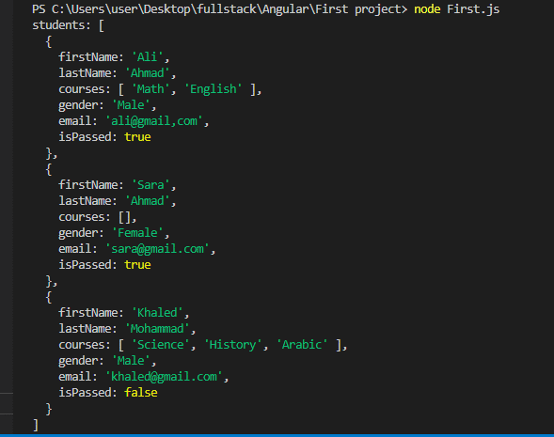

1. based on exercise one, create a new array that contains passed students only.

const passedStudents: any[] = students.filter((student) => student.isPassed);

console.log("passedStudents:", passedStudents);

console.log("_______________________________________");

3- based on exercise one, create a new array which set courses to empty [] for all students.

const studentsWithNoCourses: any[] = students.map((student) => ({...student, courses: []}));

console.log("studentsWithNoCourses:", studentsWithNoCourses);

console.log("_______________________________________");

4- based on exercise one, create a new array that contains all students who are passed or student who have course more than 0.

const studentsWithCoursesOrPassed: any[] = students.filter((student) => student.isPassed || student.courses.length > 0);

console.log("studentsWithCoursesOrPassed:", studentsWithCoursesOrPassed);

console.log("_______________________________________");

5- based on exercise one get mail students first names and last names only if they are passed.

const passedStudentsNames: string[] = passedStudents.map((student) => `${student.firstName} ${student.lastName}`);

console.log("passedStudentsNames:", passedStudentsNames);

